**Success Formulas for Email Copy Elements:**

**Subject Line:**

“Your Short, Clear Path to Value…”

Effective emails concisely answer “why should I click?”

The primary metric to gauge subject line effectiveness is open rate.

A key dependent factor for subject line effectiveness is alignment between message and audience.

Save new, or sophisticated topics for the body where it can be explained when possible.   
  
The average benchmark for Smartmail Open Rates: is 17.5%

Examples of effective subject lines by Open Rate & audience alignment include:

* “Advancing Healthcare Technology to Protect Veterans” – Open Rate 49.1%
  + Targeted Healthcare IT professionals with interests in policy, regulation, quality, and safety. “Protect” was a term that helped this subject line resonate with this audience.
* “Assessing the Impacts of Healthcare MAP Activity” – Open Rate 47.9%
  + Targeted decision-makers at payer and provider organizations where “Mergers, Acquisitions and Partnerships” (MAP) efforts are prioritized.
* “Focus Your Future with UNE Online” – Open Rate 43.1%
  + Targeted engaged audience with a high interest in medical records, data, analytics and technology resembling future-development research behaviors. “Your Future” resonated with this primarily student / researcher modeled audience.

**Body Copy:**

Effective body copy is rich enough to provide a substantive, intriguing picture around the topic, event, or content asset being promoted. Still, it wastes no words in illustrating the value in converting on the ultimate call to action.

Key elements include:

* Bulletted takeaways when appropriate
* Simple, clear descriptions
* Compounding appeals
* A quick end to ensure the call to action appears above the fold

The primary success metric for effective copy is the Click-to-Open Rate, which illustrates effectiveness converting the initial interest (shown in the open) to action via the click.

The average benchmark for Smartmail Click-to-Open Rates: 8.4%

Harvard University: CTO Rate: 46.5%



*Note, the primary body copy ensures the primary call-to-action appears above the fold. For deeper explanations or text-heavy elements, added copy can be included, but a secondary call-to-action was used as well in the second half of this email to repeat the formula of brief copy + CTA.

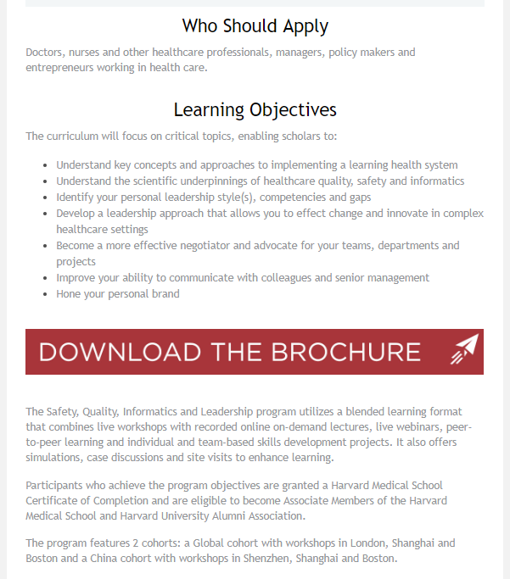

Connection, CTO Rate 25.4%

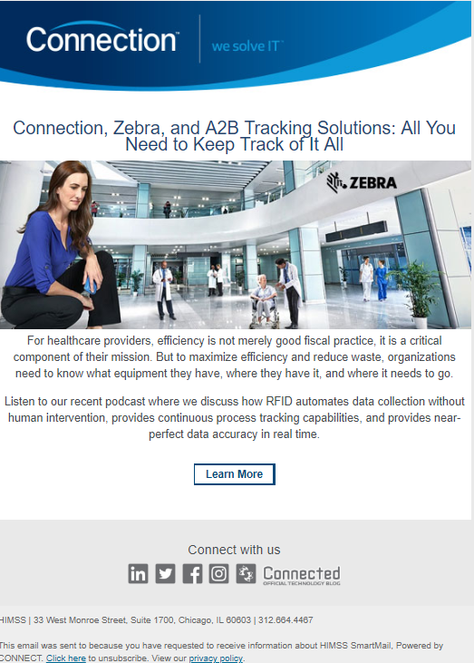

Copy is concise, descriptive, and extremely value-oriented. Everything renders without needing to scroll, so interest can immediately shift to action.

**Call to Action:**

This is the anchor of your email. It should be prominent, in-synch with the language used in the rest of the email, and ultimately, easy to act on.

Click Rate is the primary indicator of an effective Call-to-Action.

The average benchmark for Smartmail Click Rate: 1.8%

Examples of effective CTAs:   
  
Northwestern, Click Rate: 7.2%

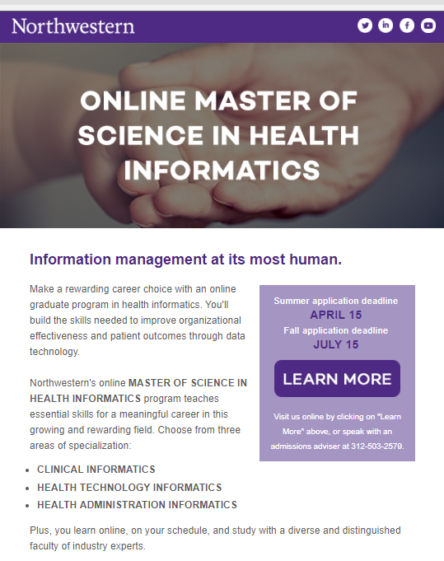

Cerner, Click Rate: 2.7%

